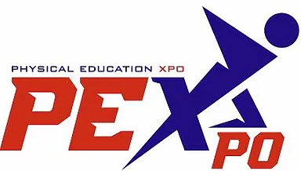2023
To the PE Department/Sports Teacher/TY Coordinator,

We would like to invite entries from your school to the 8th annual Theory of Physical Education (PE Expo) at Dublin City University (DCU). Students will demonstrate their knowledge and understanding in one of the following category titles:

- I.C.T. and Sports Photography
- Power of Sport – Inclusion & Cultural
- Wellbeing - Physical, Mental & Social
- Components of Fitness – the Science behind Sport
- Nutrition
- Games Development & Teaching Games for Understanding (TGFU)
- Sports Psychology
- Leaving Cert PE Project (Performance Assessment, Analysis or Theory)
- Senior Cycle PE Portfolio Project

Important information and key dates for your diary:

- Entries must be received by Thursday, March 16th 2023 – (16/3/23)
- Two categories: Junior (1st, 2nd and 3rd Years) and Senior (TY, 5th and 6th Years)
- Students can enter individual or group projects. (Maximum of students for Group Projects)
- Entries cost €20 per student.
- Students must wear school uniforms on the day of the competition.
- Date and Venue: The competition will take place on Wednesday, 29th March 2023 at Dublin City University (DCU) – Glasnevin, Dublin 9.

Invited judges will select the best exhibition form the Junior and Senior Sections that will win €250 respectively as well as medals and trophies that will be awarded for each of the above 9 categories.

Format of Competition Day

08.30 am – 10.00 am – Set up Exhibitions
10.00 am – 13.00 pm – Presentation of Exhibitions
13.00 pm – 14.00 pm – Celebrity Q & A on the Couch
14.00 pm – 15.00 pm – Presentation of Awards

Enquiries about PE Expo 2023 can be made by email at pexpoireland@gmail.com or by visiting our website www.pexpoireland.com. If you require information by phone contact Paddy O'Reilly on 0861743836.

Applications can be made on our website homepage by clicking the "ENTER NOW" button.

We look forward to hearing from you and seeing your exciting entries.

Kind regards,

The PE Expo Committee
